**VIDEO GUIDE: Insect Classification**

**Directions:** Use the videos below to answer the questions and fill in the table on each order.

1. Try using this dichotomous key to identify this fictitious species. The body is considered anything below the head (use your fingers to measure). What species is it?

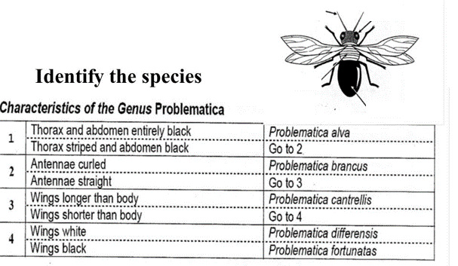

1 – striped thorax  
2 – straight  
3 – longer  
**Problematica cantrellis**

1. Describe the four main characteristics of an insect.

**Adult insects have 3 pairs of legs, 0-2 pairs of wings, 1 pair of antennae, and 3 body regions – the head, thorax, and abdomen.**

1. Fill in the 3 body segment names.

**head**

**thorax**

**abdomen**

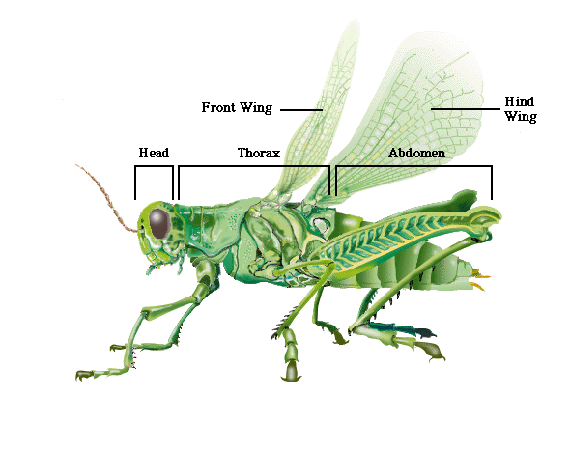

1. Describe the main difference between Hemiptera and the organisms that were previously classified as Homoptera.

**Homopterans have uniform wing texture, while hemipterans have half-wings. Homopterans have a smaller proboscis used for sucking juice from vascular plants.**

1. Fill in the table of orders.

|  |  |  |  |  |  |
| --- | --- | --- | --- | --- | --- |
| **Insect Order** | **Examples** | **Type of Metamorphosis** | **Type of Mouthpart** | **Type of Wings** | **Additional Identifying Characteristics** |
| Zygentoma | Silverfish, firebrats | ametabolous | chewing | wingless | Love chewing on paper in moist environments, 2 cerci and 1 caudal filament at the back end (looks like 3 antennae) |
| Ephemeroptera | mayflies | hemimetabulous | Vestigial mouth parts (adult) | 1 pair of triangular | Mature Imago have long antennae and *really* long filaments on the back |
| Odonata | Damselflies, dragonflies | hemimetabulous | Prehensile labium (extendable jaws under the head)  predaceous | 2 pairs of wings (reticulate venation) damsel: equal sized pairs dragon: rear pair larger | Large eyes proportionally to head long and thin abdomen  damselflies can fold their wings back, dragonflies can’t |
| Dermaptera | earwigs | hemimetabulous | chewing | Front pair is a smaller protective pair (tegmina) rear pair is membranous and fan-shaped | Pincer-like cerci at the back |
| Orthoptera | Grasshoppers, crickets, katydids, locusts | hemimetabulous | chewing | Forewings are hardened larger fan-like rear wings  Neopteran (folding wings) | Large hind legs for jumping large compound eyes short antennae = grasshopper  long antennae = katydid  tympanum (ear) in front tibia (first abdominal segment) for locating other individuals of the species |
| Phasmatodea | Stick insects | hemimetabulous | chewing | 2 pairs, some species have 0  Neopteran (folding wings) | Short or long thin antennae  look like sticks/leaves/grass |
| Mantodea | Praying mantis | hemimetabulous | predaceous | Some have wings, some don’t  Neopteran (folding wings) | Triangular head, big eyes  big raptoral forelegs for catching prey |
| Blattodea | Cockroaches | hemimetabulous | chewing | Neopteran (folding wings)  leathery forewings  membranous hind wings | Filiform antennae  dorsoventrally flattened  cursoral legs (optimized for running)  pronotum (plate that covers thorax and back of head) |
| termites | hemimetabulous | chewing | Neopteran (folding wings) | termites look like ==== ants look like o-o-o  ant antennae are elbowed ( W )  termite antennae are beaded ( V ) |
| Thysanoptera | thrips | hemimetabulous | Unique mouthparts  cone-like mouth sucks juice out of plants (or in some cases other insects/thrips) | 2 pairs of wings with long hairs (look like feathers) |  |
| Hemiptera | aphids  cicadas  planthoppers  leafhoppers  shield bugs  “true bugs” | hemimetabulous | Piercing-sucking mouthparts | “half wings” | Stickbug = not bug  stink bug = bug (separate word)  triangular scutellum over thorax  proboscis on underside of head capsule |
| Neuroptera | Lacewings, mantidflies, antlions | Complete metamorphosis | chewing | Neopterous  4 membranous wings |  |
| Coleoptera | beetles | Complete metamorphosis | chewing | Front wings are hardened into a casing (elytra) | Most diverse insect order  all species have an elytra shell over their hind wings |
| Diptera | True flies  horse fly  bee fly  lovebug  crane fly  mosquito | Complete metamorphosis | Piercing-sucking mouthpiece  cutting-sponging in some groups | 2 membranous wings | Big compound eyes |
| Siphonaptera | fleas | holometabolous | piercing-sucking | wingless | Laterally flattened |
| Lepidoptera | Butterflies, moths | holometabolous | Chewing mouthparts (caterpillar)  Adult – siphoning proboscis | Large scaled membranous wings | Moths – antennae taper to a point  thick bodied  wings lay against abdomen at rest  nocturnal |
| Butterflies are active during the day  club-shaped antennae  wings out at rest |
| Hymenoptera | ants  bees  wasps | holometabolous | Different species have different diets + mouthparts | Most species have 2 pairs of membranous wings + hamuli |  |